April
2017
Nam id velit non risus consequat iaculis.

Be as prepared as possible for the AP by following this guideline  College Board Answers to FRQs  List of Topics to Review!  Great video about how to tackle the FRQ section  https://docs.google.com/document/d/1pdd63SNQcrtytpPgqw23HYmUKC3wloJAmEFIN6dQfUA/edi | 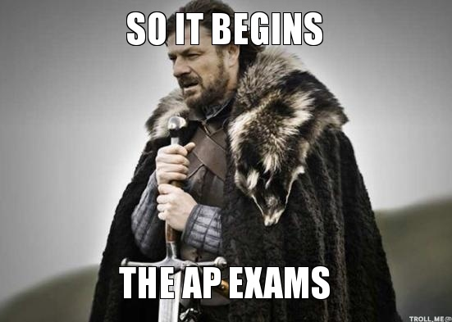

Sunday | Monday | Tuesday | Wednesday | Thursday | Friday | Saturday
 |  |  |  |  |  | 1
2 | 3 | 4 | 5 | 6 | 7 | 8
 | No class | 2010 FRQ | No class | 2011 FRQ | No class
9 | 10 | 11 | 12 | 13 | 14 | 15
 | Spring Break:  Do Barron’s Practice Exam #1 | No class | No class | No class | Work on Battleship
16 | 17 | 18 | 19 | 20 | 21 | 22
 | Code HS Practice Exam – MC | Code HS Practice Exam – FRQ | No class | 2016 Exam MC | 2016 Exam FRQ
23 | 24 | 25 | 26 | 27 | 28 | 29
 | Review 2016 Exam Answers | FINAL EXAM FRQ | No class | FINAL EXAM  MC  (Modeled on AP Exam) | Review Final
30
 | Review Final | May 2 – EXAM!! | No class | MOVIE! | MOVIE!

